

Platform Engineer Assignment:
Eleta Ilias

March 12, 2021

Table of Contents
1. INTRODUCTION 3
1.1 PURPOSE OF THIS DOCUMENT 3
2. SOFTWARE PREREQUISITES 3
2.1 PROGRAMS USED 3
3. ASSIGNMENT EXPLANATION 4
3.1 THE PROGRAM WORKFLOW 4
3.2 PRODUCER CODE EXPLANATION (producer.php) 4
Connection 4
API Endpoint 6
Creating the Routing Key 6
Message Body 7
Queue Bind 9
Basic Publish 9
3.3 CONSUMER CODE EXPLANATION (consumer.php) 10
Connection 10
$callback variable 11
The $callback variable 13
4. UNRESOLVED ISSUES 15
5. TESTING 16
6. PROBLEM SOLVING PROCESS 22

INTRODUCTION

1.1 PURPOSE OF THIS DOCUMENT

The purpose of this document is to provide all the basic necessary info regarding the Platform Engineer Assignment

SOFTWARE PREREQUISITES

2.1 PROGRAMS USED

- For IDE I used PHPSTORM.
- I only used Symfony 4 but only for the project set up.
- I downloaded XAMPP.
- RabbitMQ and Erlang.

ASSIGNMENT EXPLANATION

3.1 THE PROGRAM WORKFLOW
The workflow of the program, consists of two main levels:
- The producer who takes an API endpoint, creates a routing key with the given Id’s and publishes the message to a RabbitMQ instance.
- The consumer who takes the message from the RabbitMQ instance and inserts it to a database named cand_e2ro.
The related configuration and functionality are separated into three classes.
- The class config.php where I set up my configuration variables and I retrieve them through “get-type” functions.
- The class messsageQueueService.php which contains all the functions related to the Message Queue set up and connectivity.
- The class dbService.php which contains all the functions related to the Database calls my implementation needs to make.
- The class helpers.php which contains all the functions related to data handling - formatting - set up for clearance in the basic implementation files.

3.2 PRODUCER CODE EXPLANATION (producer.php)
Before we take our data from the API endpoint, we must create a connection first to the RabbitMQ service and set up the message queue settings.

Connection

The functions to set up the connection are in the class named messageQueueService.php and the message queue details (including the API endpoint URL) are declared to the class named config.php.
- The message queue details are created in the function get_amqp_connection where it returns the constant details of the message queue (host, port, username, password)
- After that, the set_up_channel function is used to set up the connection to the RabbitMQ channel and declare the queue and the exchange of that channel.
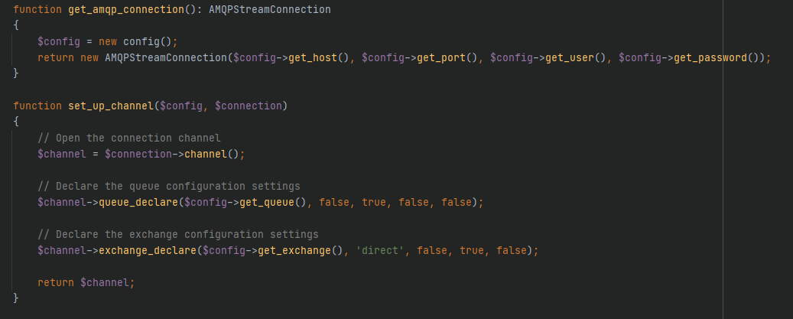
In order to create the connection in our producer.php file
- We initialize an object of the config class and the messageQueueService into two variables in our scope. ($config, $messageQueueService)
- We set up our connection in a variable through the function get_amqp_connection from our service instance. ($connection)
- We set up our communication channel in a variable through the function set_up_channel from our service instance. ($channel)
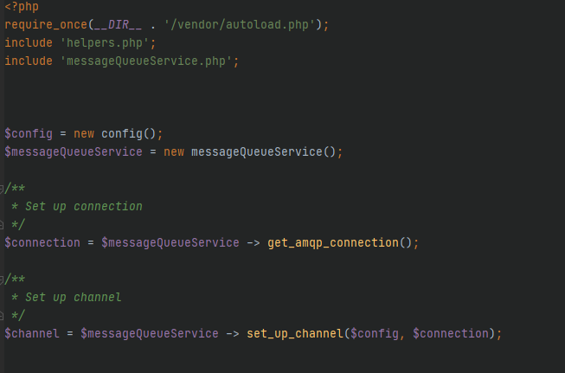
Now that the connection is set up, we need to retrieve the necessary information from the API endpoint and create a routing key and the message body based on the assignment specification.

API Endpoint

- Since it is a URL, I used the Client URL Library (cURL) functions. In my helpers.php file I created a custom function were
  - I pass the URL as a variable.
  - I retrieve the response body.
  - I return the decoded message through json_decode.
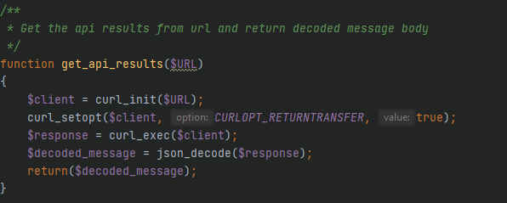
- In the producer.php file I use the function to retrieve my decoded message in a local variable named $result.
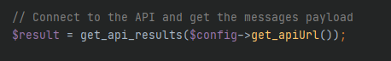

Creating the Routing Key

To create a valid routing key (according to assignment specification) I needed to get the decimal equivalent id’s (profileId, endpointId etc) from my payload, since the API result was providing the info in hexadecimal format (0x). After that I needed to correctly format the routing key in the specified format (X.X.X.X)
- In order to do that, I created two functions in the helpers.php file named hex_to_dec and set_formated_routing_key.
  - The hex_to_dec function takes a hexadecimal number and converts it to a decimal.
  - The set_formated_routing_key returns a string message in the following format: <gateway eui>. <profile>. <endpoint>. <cluster>. <attribute>.
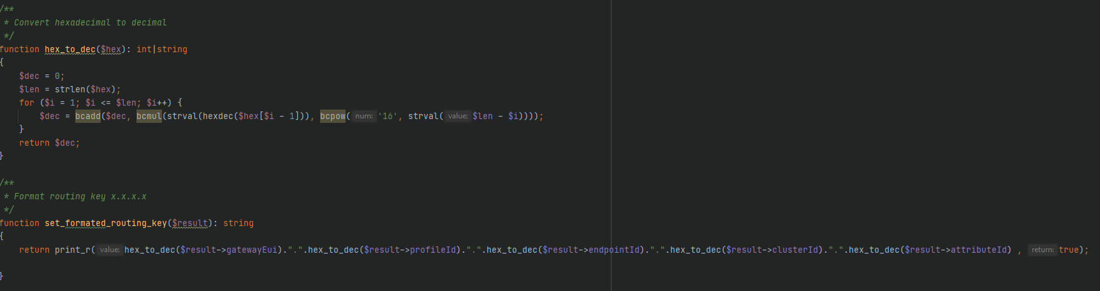
In our producer.php file we call the set_formated_routing_key to retrieve our formatted routing key and assign its value in the local variable $routing_key.
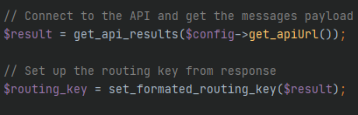

Message Body

The first thing I noticed when retrieving the payload, is that the timestamp was in Unix/Epoch format and should be converted to “human-friendly” date.
- I created a new function in the helper.php file named unix_to_utc_formatted which return a formatted date string (Year-Month-Day Hour: Minutes: Seconds) in UTC.
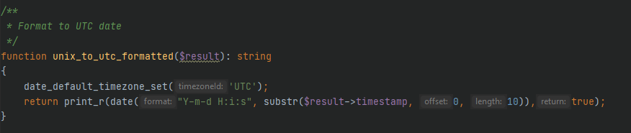
- I decided to post the values (timestamp, value) in json so that it would be easier to consume later. In order to encode them in json, I added the values into an array and assigned the array in the local variable $result_message.
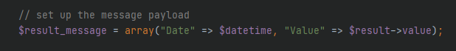
- Before we publish the message to RabbitMQ we must set the AMQP message. I created a function in my services file (messageQueueService.php) where we return a new instance of AMQPMessage class with
  - content_type: application/json => since our message is in json format
  - delivery_mode: 2 (persistent) => to make our message persistent
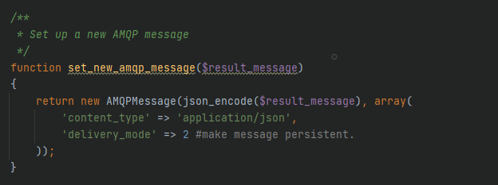

Queue Bind

After that we go and bind our queue with the exchange based on our routing key. The queue_bind function belongs to the AMQPStreamConnection.

Basic Publish

After that we publish our message in the channel (queue - exchange) through the function basic_publish of the channel which belongs to the AMQPStreamConnection library.
The Whole Process of the producer.php (without the connection setup)
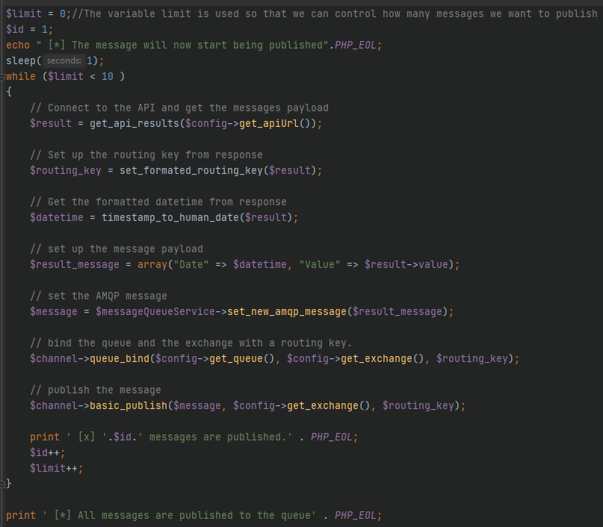

CONSUMER CODE EXPLANATION (consumer.php)

Connection

The connection process is the same as the one in the producer.php file.
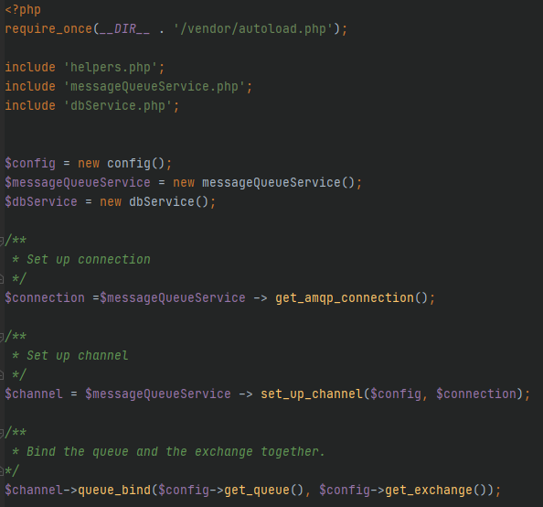

The idea here is that since we are binding to the same exchange, we can consume the information published from the producer with the basic_consume function which belongs to the AMQPStreamConnections library.
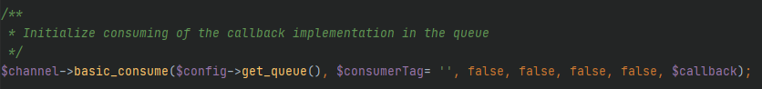

$callback variable

- $callback is the function “doing all the work”. We declare with the published message as a parameter. The message is the one that we had set in the producer.php which is now consumed with the help of the basic_consume function.
- Since we have the message body “json encoded” from the producer.php, we decode with json_decode and assign the result to the $messageBody variable.
- In order to insert all the values in the database, we need all the values from the API, but we only have the routing key and the message body.
- Since the routing key is a formatted combination of the related identification values, we created a function in the helpers.php file named get_routing_key to retrieve initially it’s value from the delivery_info object of the message. (name of object variable => delivery_tag)
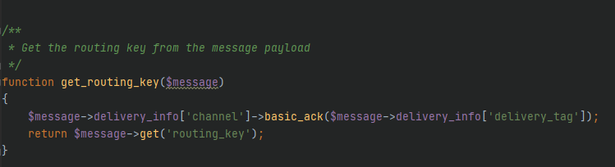
- Now that we have our routing key, we can parse it to retrieve the original Id’s and turn them to integers. We are doing that with the help of the get_routing_ids_in_array function in the helpers.php.
  - There, we split the routing_key string by the separator “.”
  - Populate an array with the values and return the integer array with our Id’s.
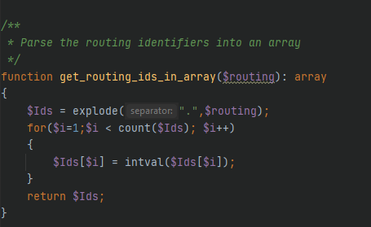
- I use the create_db function from the dbService.php class where we create the
database with the given details
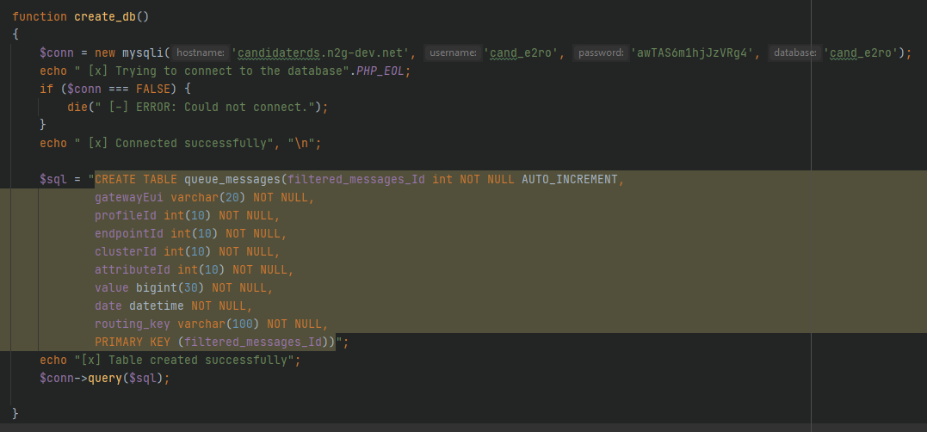
- The Database schema shown below.
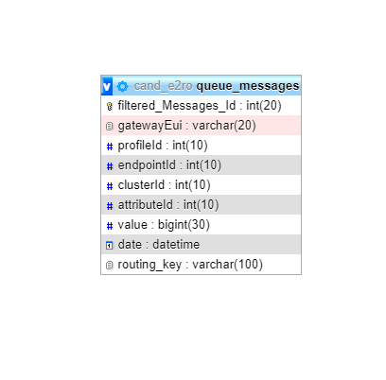

- Lastly, I created the insert_to_database function which belongs to the dbService.php class as well, and its job is to insert our consumed data to the created database.

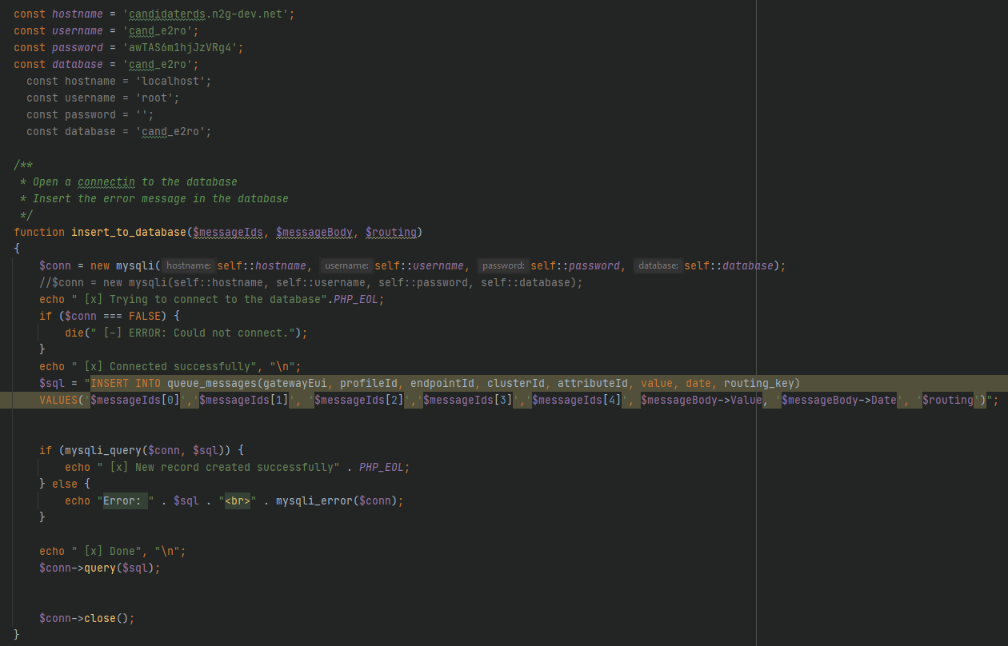

The $callback variable

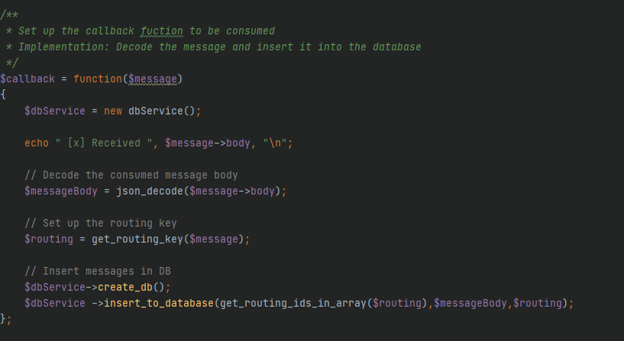
After the setup of the consumer, it will keep waiting for messages indefinitely. (unless we press Ctrl + C).
- In order to make the consumer stop automatically when there are no messages in the feed, I created a function named initialize_channel inside the helpers.php file. This function is basically an “exception handler” when there are not any messages to consume, we make the consumer to wait (sleep) for as long the $timeout variable is set and then it will automatically stop.
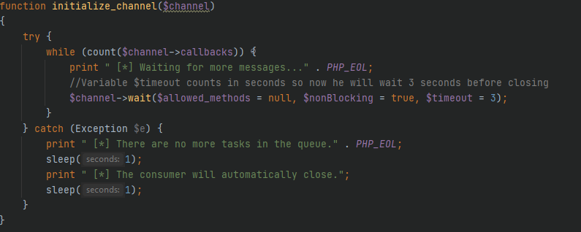
The Whole Process of the consumer.php (without the connection setup)
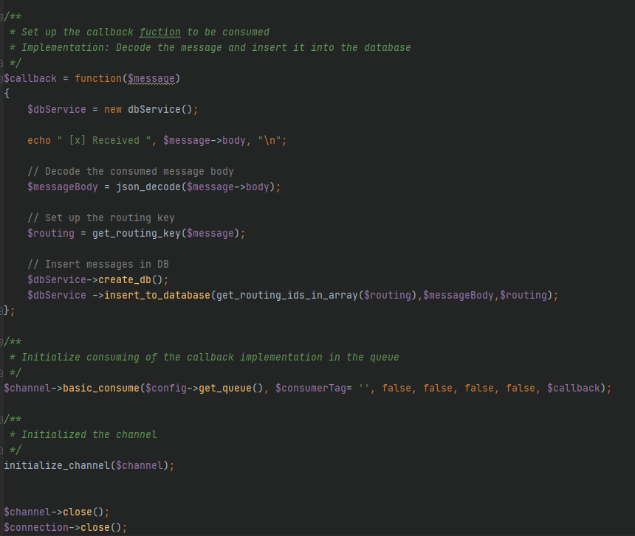

UNRESOLVED ISSUES

The problem that I encountered, and I couldn’t overcome was that I couldn’t change the node name on RabbitMQ, so the hostname is ‘127.0.0.1’ and not ‘rabbitmq.candidatemq.n2g-dev.net’, so I am running RabbitMQ locally.

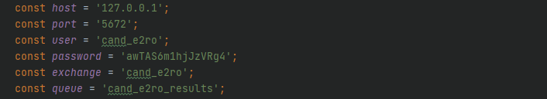

TESTING
In order to run the project successfully we must insert the project file(net2grid) to the correct directory. We go to our downloaded xampp file.
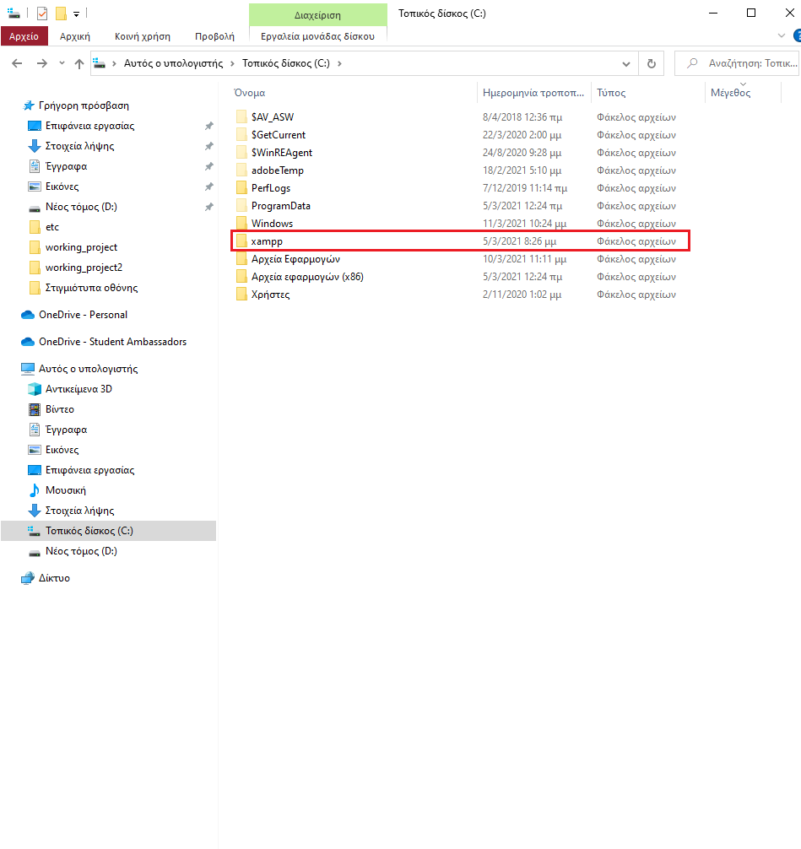
Then, we place the project file(net2grid) inside the htdocs file.
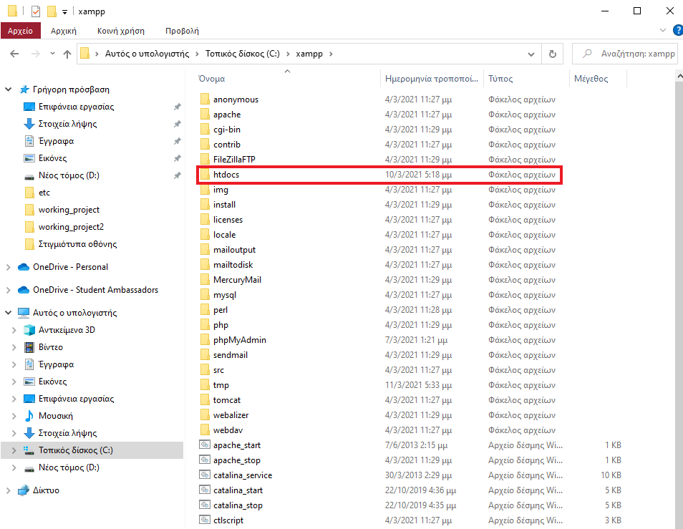
Now in order to run the program we must go inside the htdocs file and right click our project (net2grid) and click Git Bash Here
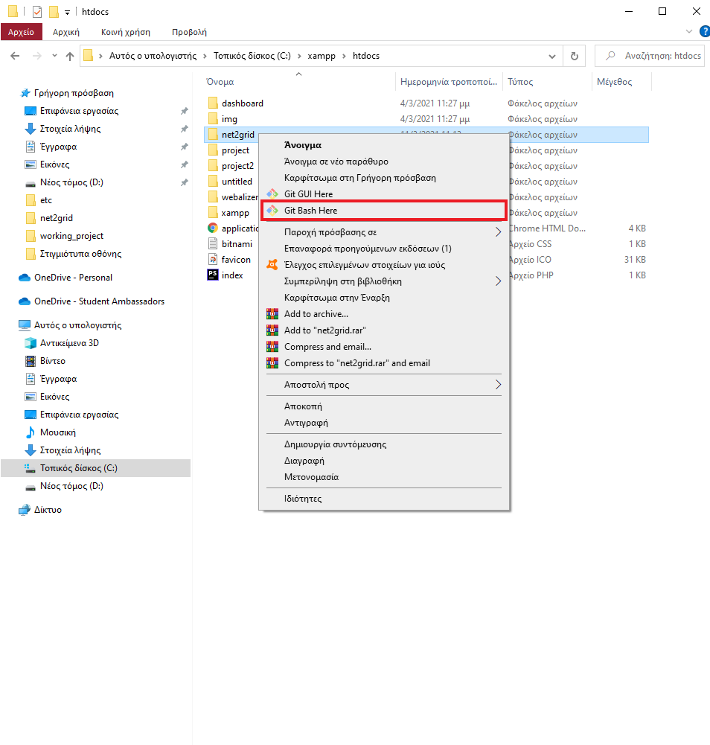
After we do that, a black window will show up where we can run our project where we type inside of it the command (php producer.php).
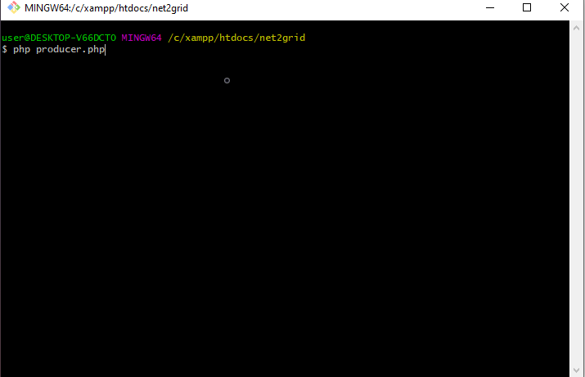
When we will hit enter the program will now start running and publish the messages to RabbitMQ
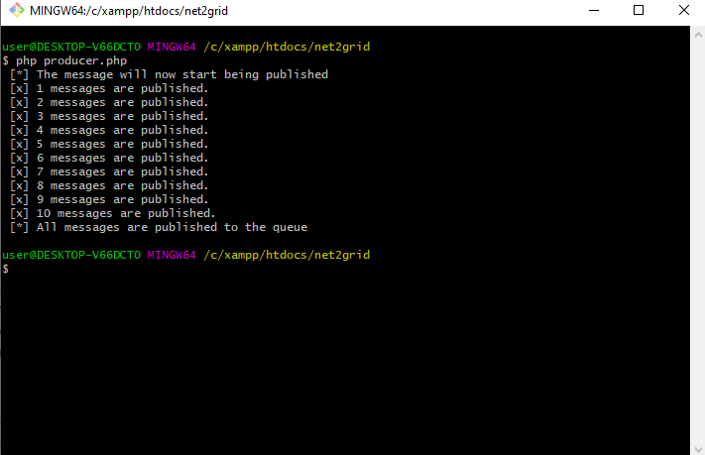

If we head to the RabbitMQ Management, we can see that a queue and an exchange were made and that the messages were sent with their binding key.

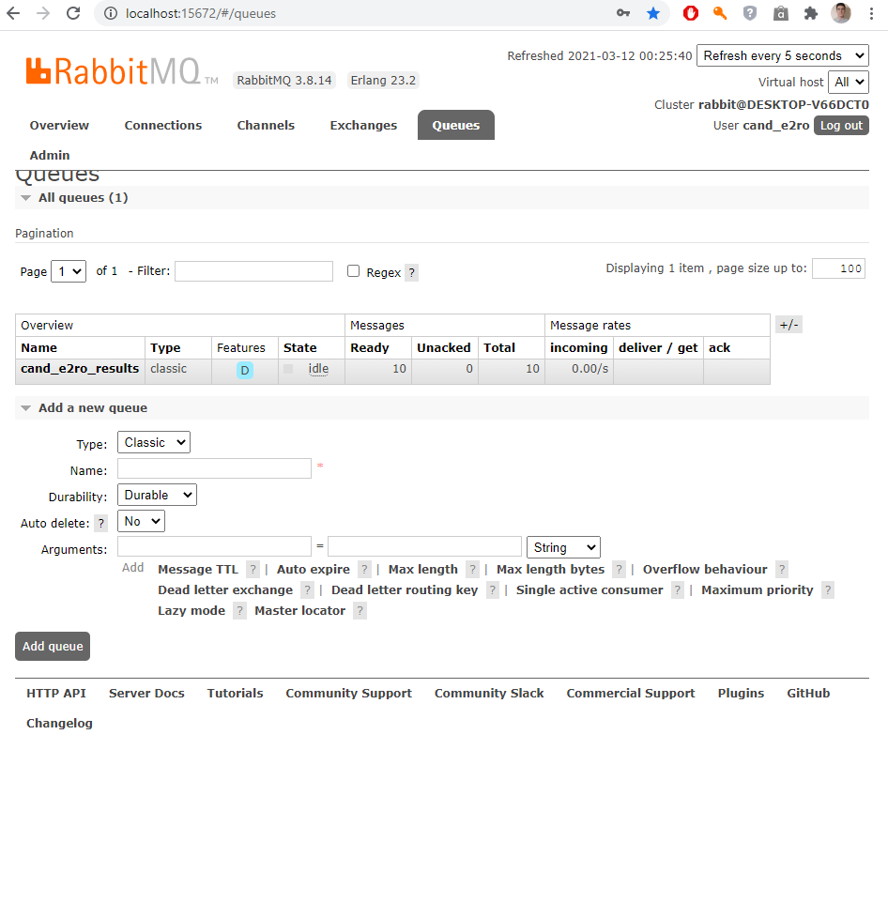
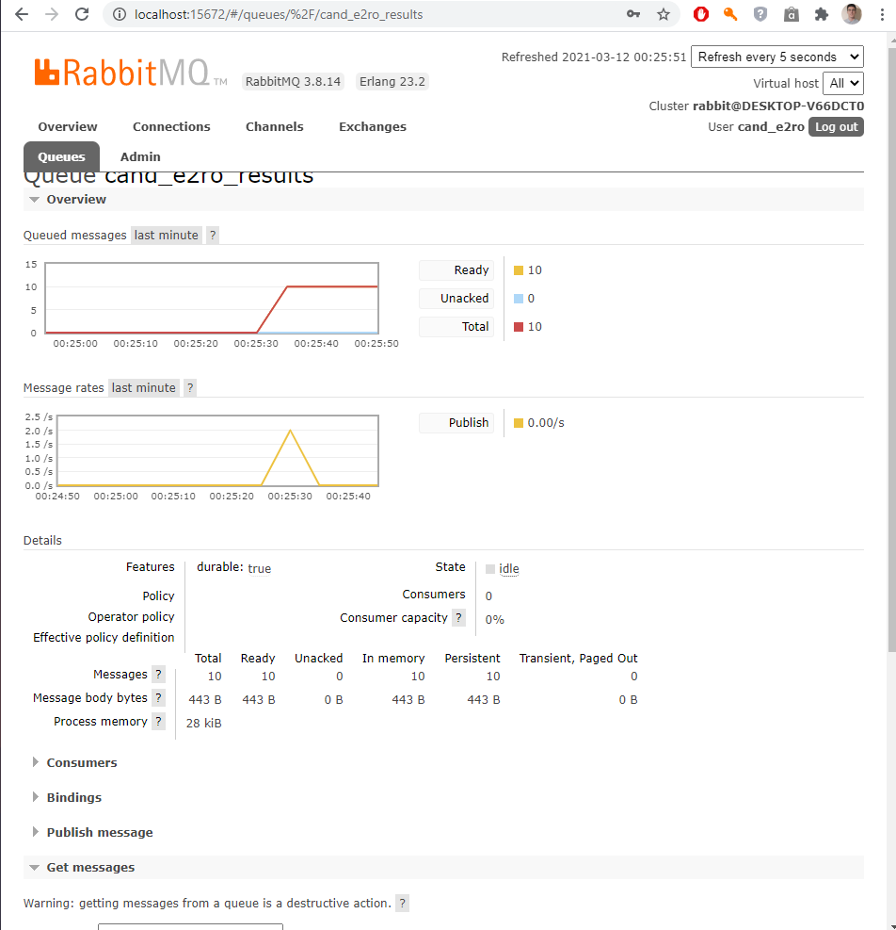
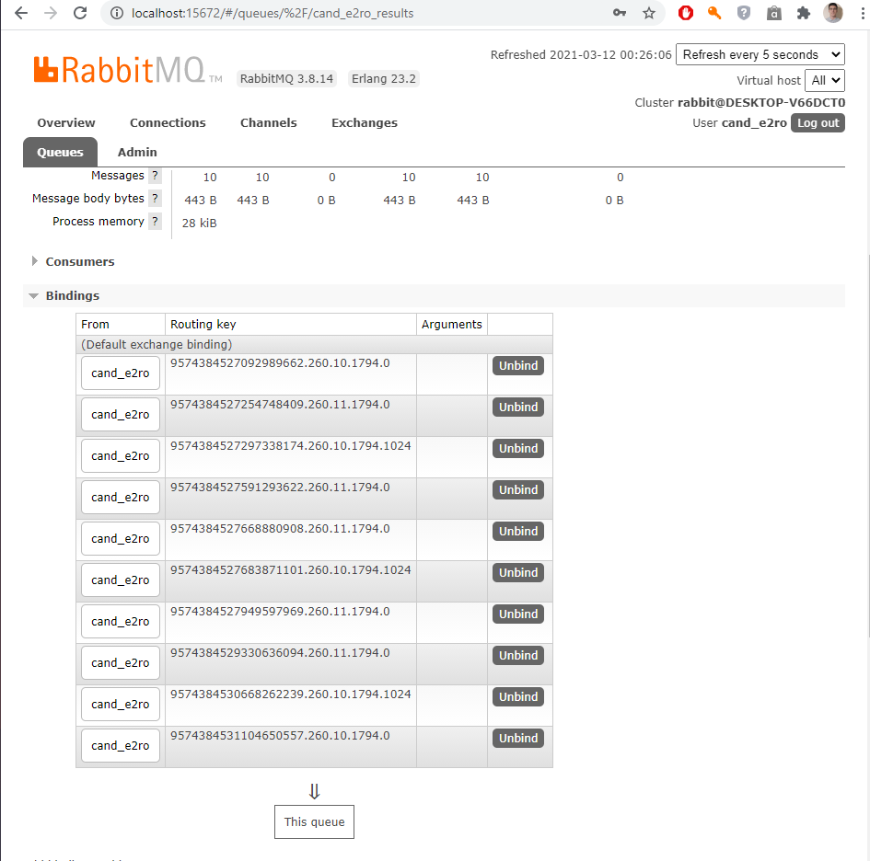
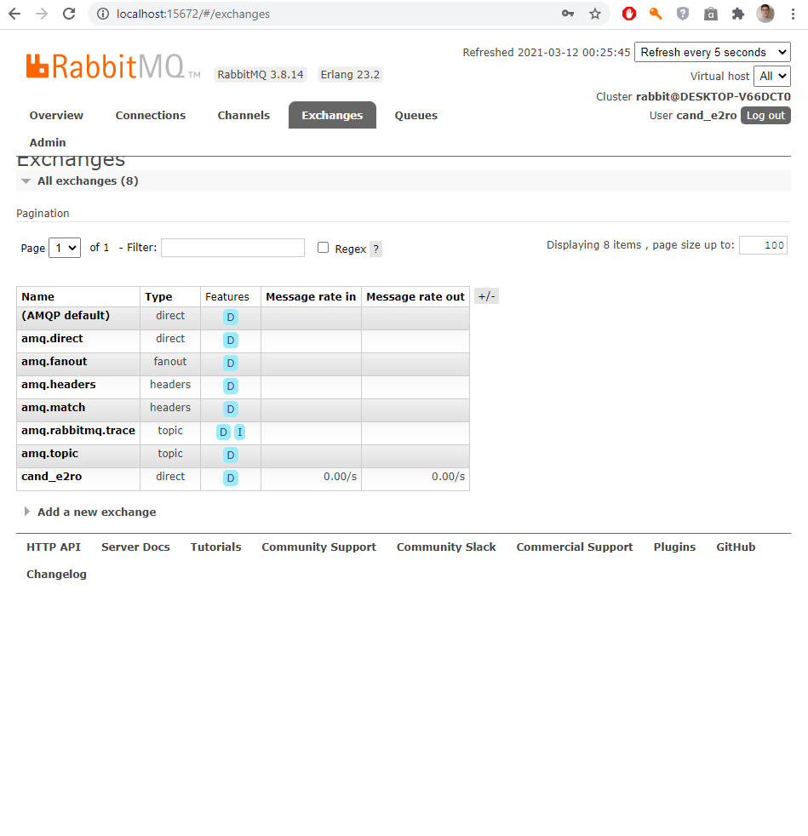
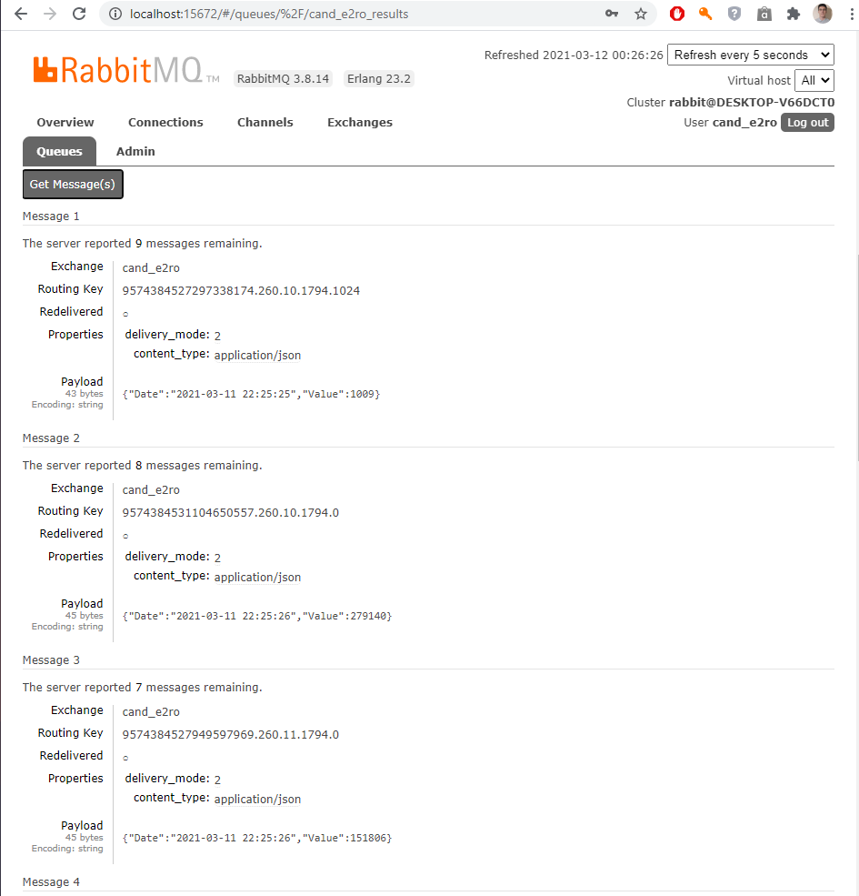

In the Get Message(s) we can see the messages that were uploaded, we can see routing key and the properties of the Payload.
Now that the producer.php runs successfully it’s time to consume these data with the consumer.php file. Like we did before we go back to our project and click Git Bash Here and instead of typing php producer.php now we will type php consumer.php

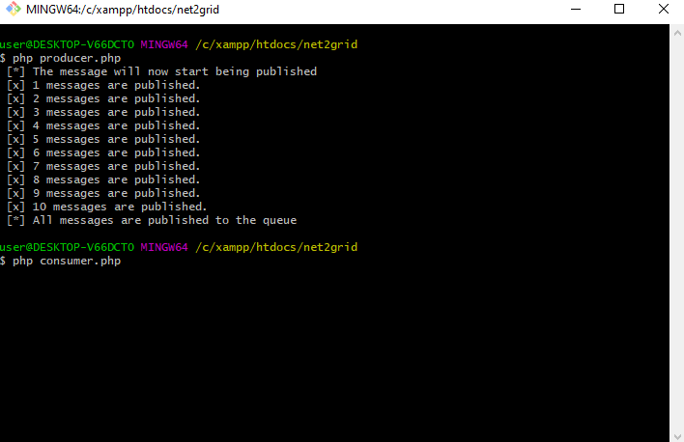
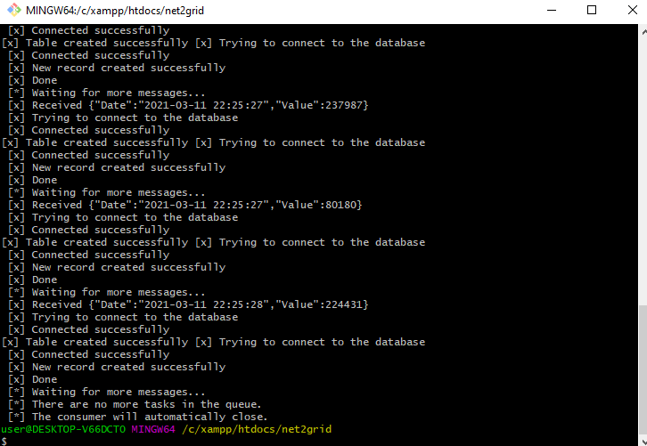
We can see that the consumer stops by himself when there are not any other messages in the queue, which payloads are we consuming from RabbitMQ and inserting them to the database to the correct format.

PROBLEM SOLVING PROCESS
The process I followed for my implementation consists of the steps below
- Clarify the Implementation: The requirement was to publish messages in RabbitMQ, consume those messages from the published queues and save them in a Database.
- Breakdown the Implementation: The implementation consists of the following parts
  - Set up RabbitMQ.
  - Retrieve my data from the source.
  - Understand the type of data that I am using.
  - Create the necessary data structure to save my data.
  - Create the necessary implementation to publish my data in the Queue. (producer)
  - Create the necessary implementation to consume my data from the Queue. (consumer)
  - Make the necessary filtering of the messages I am consuming.
  - Save my data to my data structure.
- Develop/Setup the related parts: Based on the above breakdown
  - I followed the related documentation on the technical parts (RabbitMQ, XAMPP, OOP)
  - I analyzed the business parts (data structure, formatting etc.)
  - I developed the code to meet the needs of my implementation by running a “try-error-retry” logic
  - For each step I performed manual functional testing to make sure my code was working as expected
- Complete Testing: Once I had all my parts in place I performed end to end testing with inline messages that would track my connection – data - output etc. to make sure everything works as expected.
- Refactor: I spend some time to re-evaluate the positioning of my functions, the structure of my code and the “architecture” of the solution and made the changes I felt were “logically” needed to achieve a “separation of concerns”.
- Complete Testing: After my refactoring I performed again end to end testing to make sure nothing was broken from my changes.
- Beautify: While I believe I tried to make the code self-explanatory with the naming of my methods, I added comments in order to make it easier to read and document.
- Complete Testing: I performed one last end to end testing for verification
- Documentation: I documented my implementation with this document.

https://www.php.net/manual/en/book.curl.php
https://www.php.net/manual/en/function.json-decode.php
https://en.wikipedia.org/wiki/Unix_time
https://www.w3.org/TR/NOTE-datetime
https://github.com/php-amqplib/php-amqplib/blob/master/PhpAmqpLib/Message/AMQPMessage.php
https://www.rabbitmq.com/tutorials/amqp-concepts.html
https://github.com/php-amqplib/php-amqplib/blob/master/PhpAmqpLib/Connection/AMQPStreamConnection.php
https://www.php.net/manual/en/function.sleep.php

